### **Introduction to PHP Frameworks LARAVEL**

**Create a CRUD operation for Users in Symfony:**

**User Attributes: Name, Age, Gender, Education Qualification (B.tech, MCA, Graduate, 10+2), Department (Technology, Services, Sales, HR, Accounts)**

**Routes need to be created: user/list, user/add , user/edit/{id}, user/delete/{id}**

**/User/list page should have filters on Gender, Education Qualification, and Department.**

**ADDING A USER:**

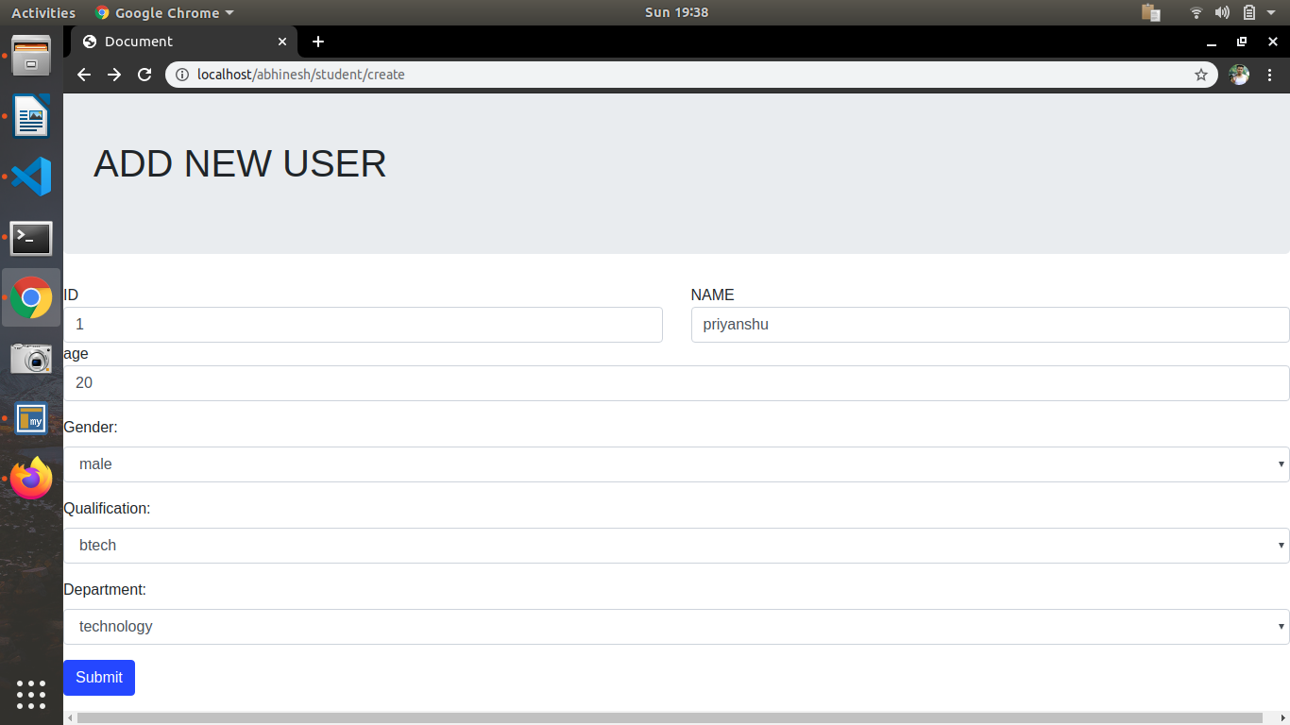

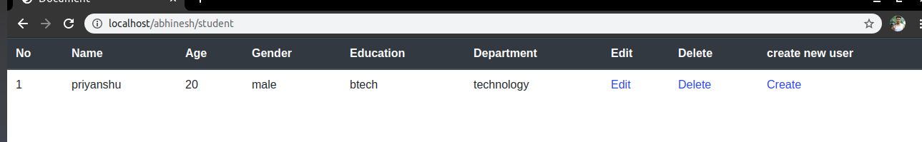

**Simillary added more users:**

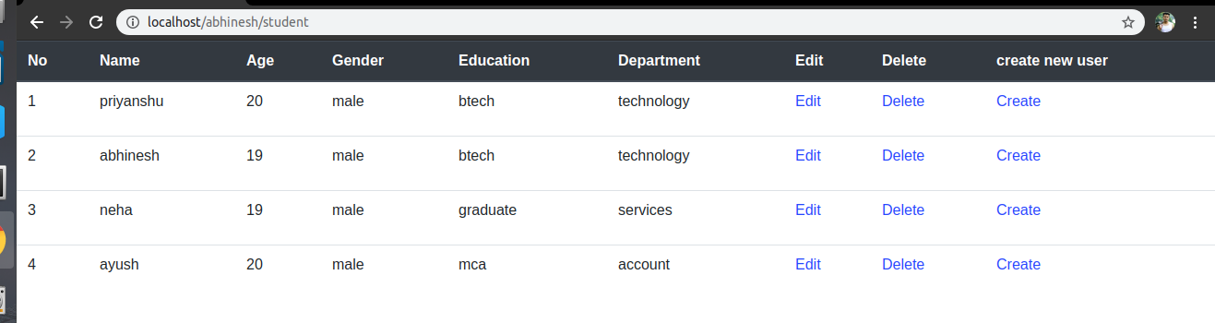

**Editing neha:**

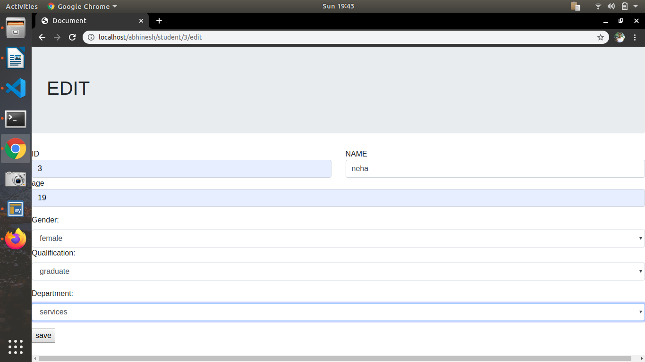

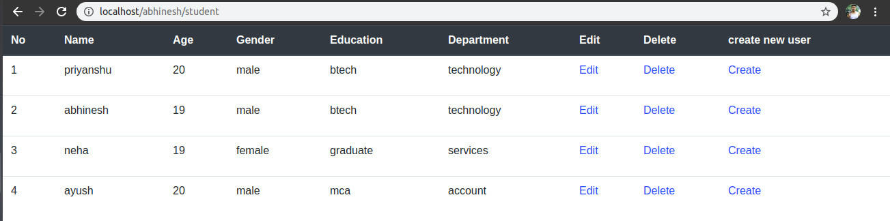

**DELETING Ayush:**

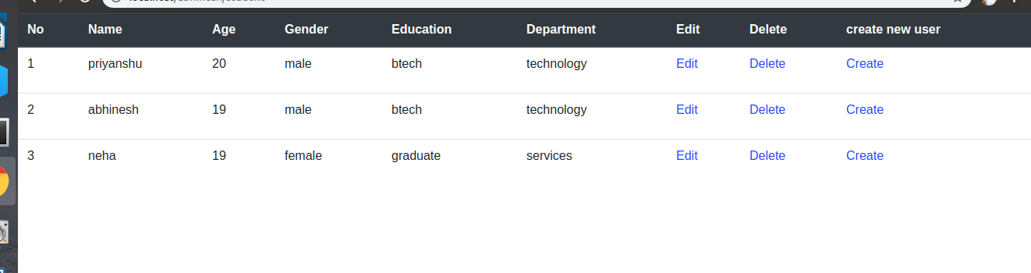

**Adding new user from create :**

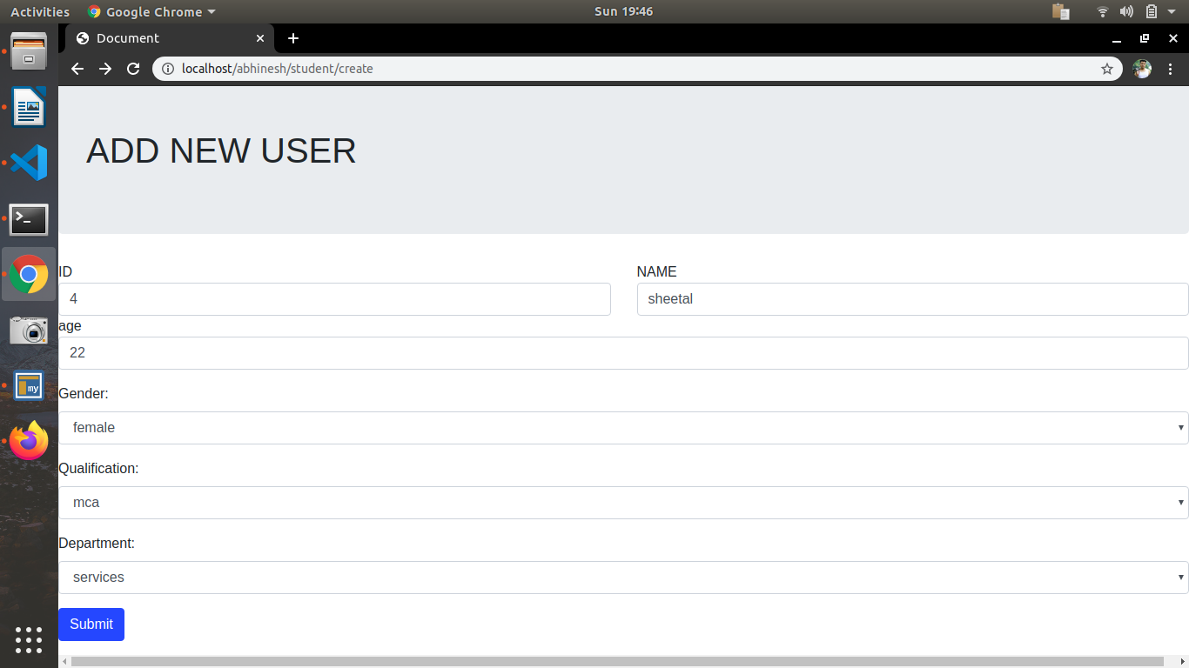

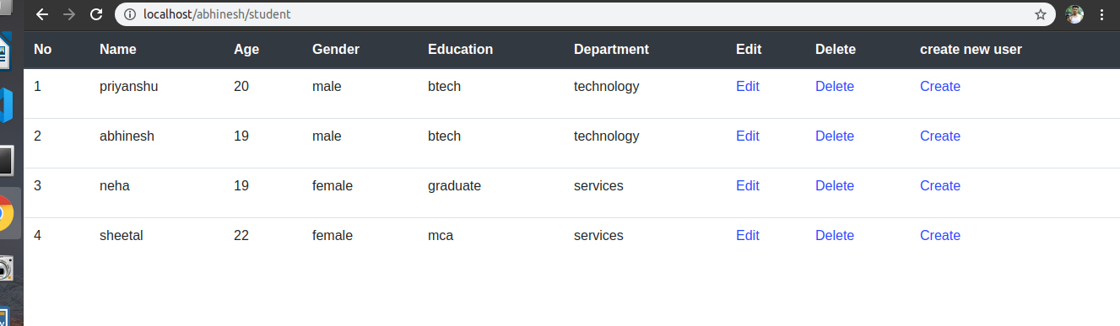

**Files created for the assignment:**

https://github.com/abhineshdhiman/assignment/tree/phpframework/phpframeworklarawell